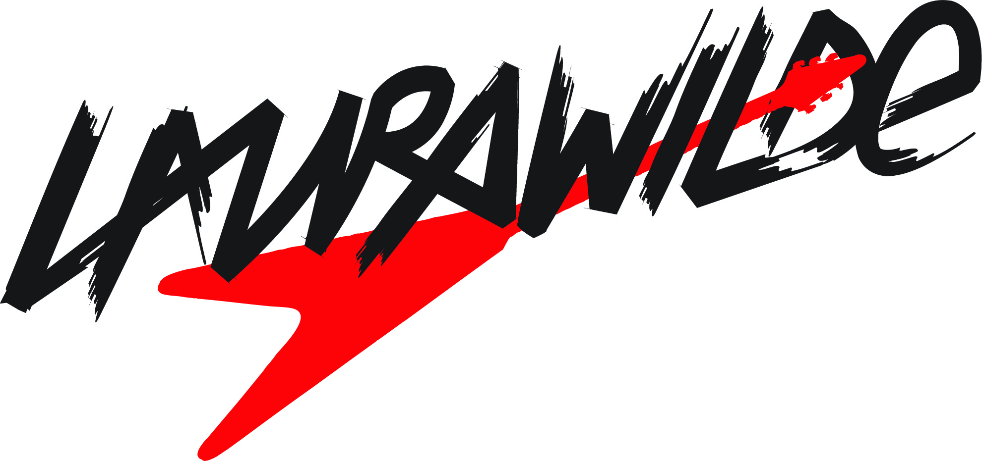

***Bio*** “I'm going my own way/Far away from here/I know it's not a game/But watch me disappear/Can you see/How I feel/Like I'm close to something real/It goes on and on and on and on…” - - “Back Seat,” Laura Wilde

“Music is pretty much the only way in which I am able to express my feelings and emotions. Being a musician is my dream job in every sense, and I enjoy all aspects of the process. I love everything from practicing to performing, from songwriting to production. It’s an unbelievably varied and interesting career to be able to pursue, and I'm quite blessed and grateful to have this amazing opportunity to do what I love exactly the way I want to do it.”

That’s Australian rocker Laura Wilde expressing her passion for music. Welcome to her world, where adventure and fun are everything, and fear and doubt are non-existent.

Laura Wilde is set to release her debut album, Sold My Soul, on January 31, 2012, and will tour and release singles and videos to support the album.

Laura is the personification of girl power, to be sure….but she’s much more than that. Look past her obvious beauty and cool Aussie accent, and you’ll find a depth and wisdom uncommon for someone only 21 years of age.

Growing up in Melbourne, Laura had a conservative upbringing where she was expected to do well at school, go to University, and have a career most parents would deem acceptable. “I ended up going to University, but to my parent's disappointment, only lasted one year,” Laura reveals. “I had to battle for years to be allowed to do music…I had to really fight to take this path, as no one took my being a musician seriously. I also attended an all-girls school, which wasn't at all conducive to playing rock guitar. I studied opera singing, as this was all that was offered. I tried to have guitar lessons, but my first guitar teacher never used to show up, so I ended up having to teach myself how to play.”

Laura not only taught herself to be an accomplished guitarist, but she also favors playing a Flying V. “I was allowed to start playing the guitar when I was 12, after years of nagging my parents. At the age of three, I saw Lenny Kravitz's music video for ‘Are You Gonna Go My Way,’ where he was playing a Flying V. I was immediately transfixed on the guitar, along with Lenny's unbelievable attitude. I have two Flying Vs, and was lucky enough to have my own signature Laura Wilde 'Flying W' created for me which was pretty special.”

Laura’s music is explosive, gritty, powerful, fearless and aggressive. Real, true rock n’ roll, which is in short supply, especially from women. Citing influences as varied as Joan Jett and Suzi Quatro to Jimmy Page, Jimi Hendrix, Slash and Dave Grohl, Laura really and truly brings the rock to her fans.

“I tend to write about my personal experiences and observations. I hope that my audience can somehow share these experiences and feel inspired and empowered. Writing is a cathartic emotional release for me. Its my way of reaching out and sharing with others as I am unable to do so verbally, in my day to day life. I don't have the most refined communication skills when it comes to my feelings. Its the only way I can unleash my emotional energy and overcome frustration. My songs are based mostly on my own life. Songwriting for me is a very therapeutic exercise to help me through whatever emotional turmoil I may find myself in.”

Laura knew if she really wanted to live her dream of becoming a working rock n’ roll musician as a career, she’d have to leave her comfort zone in Melbourne and move ¾ of the way around the world to Los Angeles. Fearless as usual, she did just that, and has never looked back. ”Australia has a much smaller population than the US, so there is less of a market for true rock n’ roll.”

Laura’s lyrics and music really express who she is as a person, and anyone can easily relate to her music, male and female alike.

The subjects Laura writes about are varied. She describes the title track of Sold My Soul as “a celebration of my coming to America and all of the amazing places I hope to see when I get out on tour. I guess it was also a bit of an American geography lesson. Now I can name and place most of the 50 states,” she laughs.

“'Nothing Back' is about having strength in your convictions and having no regrets. It’s about following though with your dreams, regardless of what other people think.

“'Back Seat' is about the instigation of change. It’s about fighting something that is holding you back from realizing your full potential, such as an addiction to either a substance or a person.”

“My goal is to write great songs that people can really relate to…songs that really speak to them and help them through something difficult, or rev them up or make them happy,” Laura concludes. “There are many songs by so many brilliant artists that really do all of these things for me. Also I’d love to be proficient on all instruments. At the moment I can play guitar, bass and drums, but I’ve finally come around to liking the piano. I’d really like to be better at all of them. So another goal is to be the best musician I can be, and to be respected by other musicians.”